.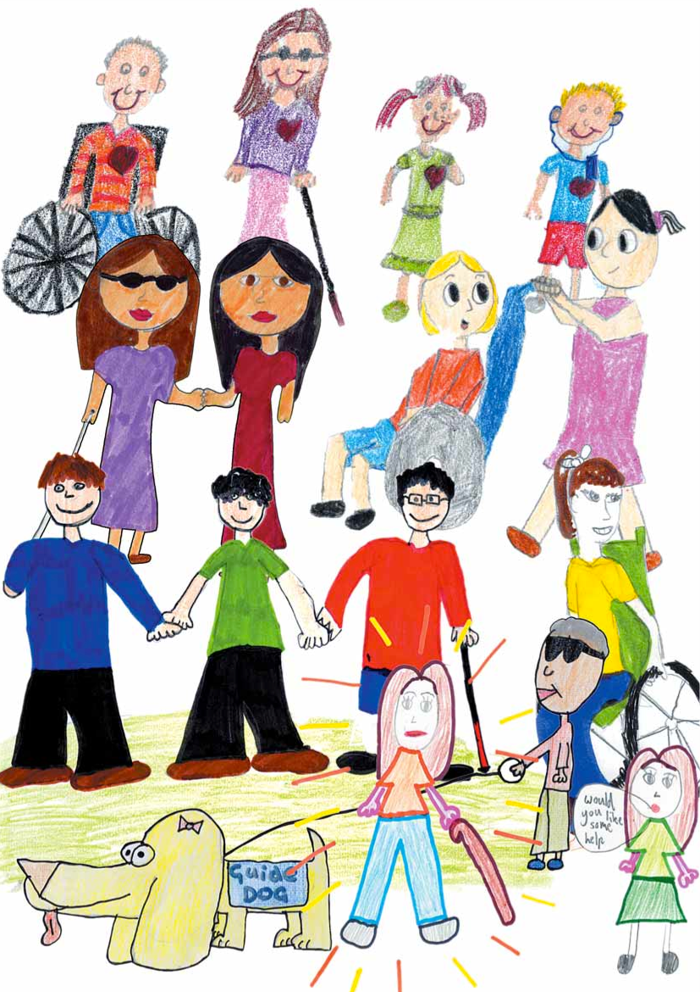
Disability Awareness Kit
An Invitation to Students
and Teachers

In 2005, children, teachers and other community members from the city of Whitehorse in Australia created pictures and put together a Disability Awareness Resource Kit. They invited others to use any or all of their materials for disability awareness in their schools.
We have borrowed some of our background material, activities and pictures from their wonderful booklet, changing some of the language and content to work for the United States. We invite students, teachers and schools to send us their own art and suggested activities to add to this resource book and our Include! website. We welcome your submissions and ideas. Our web address is www.IncludeVT.org.
If you send us your art or other material, please make sure you include your name, school and classroom teacher with your artwork or writing. Thank you for helping us bring new art, writing and ideas to disability rights and awareness work in Vermont and the United States.
A Reminder
These activities are designed to begin a conversation and exploration of understanding disability as part of our shared human experience. They are only a part of the commitment needed to make schools a place where all children are welcome and belong. The activities and games in this booklet help children and adults to try doing things differently and to consider what it is like to experience life with specific disabilities or conditions. They can help us understand why it is important to make room for human diversity in our building design, communication, communities and schools, but they must not take the place of talking with, learning from and getting to know children and adults with disabilities. No disability awareness event can fully convey an individual’s experience of disability and the social experiences of disability that many people have in their daily lives. However, awareness activities can sometimes help us step outside our own way of participating in the world and realize that human beings have many ways of doing things and diverse ways of experiencing the world. To learn more about the social and cultural experience of disability, talk to people with disabilities; include disability studies in your school curriculum; and take time to learn about disability rights history and experiences in the United States and around the world.
One school, Champlain Elementary School in Burlington, Vt., holds an annual Reading for Inclusion Day and invites individuals with different disabilities to come in and share their stories while reading and discussing books about disability. A school district in the southern part of Vermont has incorporated disability rights and awareness activities in their district’s Diversity Day. Other teachers and students have made discussions about disability a part of their conversations about life in their communities. These kinds of events can stimulate discussions that other educational and social experiences will, we hope, continue throughout the school year and beyond.
Disability Facts and Tips
The following section provides some background on types of disabilities. It describes some physical, sensory and hidden disabilities that affect how people do things or experience the world. Though disabilities are often described as a limitation or loss, many people — especially those with lifelong disabilities — do not experience their condition as a loss, but simply as part of the way they experience life. The most important thing to remember is that people with disabilities are people first and want to be known for their abilities, interests and strengths — gifts they want to share with others.
This section also provides suggestions on things to be aware of when you are with people with different disabilities. These are only suggestions. Every person with a disability experiences their disabilities and abilities in very individual ways. Getting to know individuals with disabilities and learning from them is the best way to build your own disability awareness!

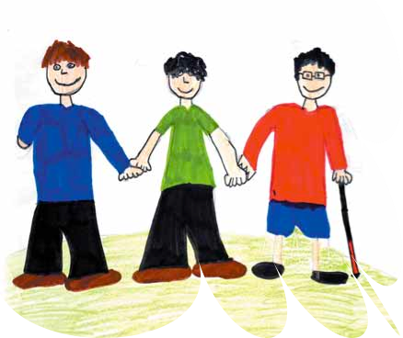
lllustration by Sam, age 12, of St Thomas the Apostle Primary School (Whitehorse, Australia)

About Physical Disabilities
The term “physical disability” refers to many different sorts of permanent conditions that limit body movement or control. Physical disability can be caused by damage to, or differences in, the spinal cord and nerves, limbs, brain or muscular systems. Physical disabilities can either be present from birth (congenital) or occur throughout a person’s life. Some examples are: cerebral palsy, spinal cord injuries, amputations or limb loss, arthritis and muscular dystrophy.
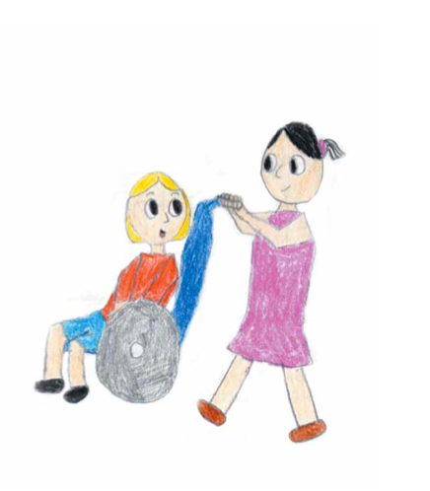
Illustration by Michelle, age 11, of St Thomas the Apostle Primary School
When you are with someone with a physical disability

Always ask if they need assistance before giving it. Often people may look as though they need help, but it is the way they do things.

If you are talking to a person in a wheelchair, try to sit down to make direct eye contact.

Speak directly to the person and not to someone who might be assisting them (or may simply be with them at the time).

Never pat a person on a head or shoulder or hang onto his or her wheelchair or anything attached to it — respect their equipment and body space.

Don’t push a person’s wheelchair without asking first if help is wanted— the person may enjoy doing things for themselves.

Try to make sure there is a clear pathway where the person in the wheelchair needs to go.

About Sensory Disabilities
The term “sensory disability” refers to a range of impairments to a person’s senses such as sight, hearing and sometimes also touch or smell.

Vision Loss or Impairment
There are different degrees of vision impairment:
• Blind: A person who is blind has a total loss of vision.
• Vision Impairment: A person who has vision loss or is partially sighted has very little eyesight and may see in very different ways than most people do.

D/deaf or Hard of Hearing
People may have many different kinds of hearing loss. People who are born with little or no hearing or lose their hearing early in life may use sign language to communicate and may describe themselves as Deaf and may not consider themselves disabled. Individuals who have some hearing or who lose their hearing after early childhood are more likely to consider themselves to be deaf, hard of hearing or hearing impaired.

Tips: When you are with someone with a sensory disability, here are some things to keep in mind.
Vision Impairment:
• Address people by their name.
• Identify yourself so the person knows who you are.
• Always ask if help is needed before giving any assistance.
• Explain any sudden noises.
• Don’t move objects without telling the person.
• Give clear directions; don't talk about "here" and "there."
• It’s OK to use words like “look” and “see.”
• Don’t push or steer the person; let the person take your arm just above the elbow.

Hearing Impairment or Deafness:
- Make sure the person is looking at you when you speak to them.
- Look directly at the person and speak clearly, especially if the person wishes to lip-read, but do not exaggerate lip movements and remember not to put your hand over your mouth while talking. Do not shout — ask the person if he or she can hear you.
- Try to find a quiet spot when you want to have a conversation.
- Don’t worry about using terms such as “did you hear about...”
- Always speak to the person, not their sign language interpreter (if they use one).

Less Visible Disabilities
Some disabilities cannot be seen. These disabilities are often hard to understand because you do not know that the person has a disability or see how it affects the body and the brain. These disabilities include intellectual disabilities that include Down syndrome, autism and developmental disabilities. Other hidden disabilities include acquired brain injuries and learning disabilities, such as dyslexia or aphasia. People may also have hidden physical or mental health conditions that limit their activities or affect how they feel.
Intellectual & Learning Disabilities
People with an intellectual or learning disability may learn and develop intellectually differently. Just as some people are quick to learn how to do certain things, others learn more slowly or need more time to learn. Sometimes people are gifted in some areas of development and have a hard time with others. A person may be born with an intellectual disability or acquire an intellectual disability later in life as a result of an accident or illness. Causes of intellectual disability can include infections, toxins, injury and prolonged lack of oxygen or genetic factors such as Down Syndrome or Fragile X Syndrome. Others with specific learning disabilities may learn some things quickly but have difficulty understanding written or spoken words, doing math, or may find it difficult to orient themselves in space or time.
Down Syndrome
Down syndrome is a genetic condition that can result in a wide variety of physical characteristics and associated conditions such as heart defects, sensory impairment, cognitive impairment, orthopedic disorders and obesity.

Autism
Autism is a condition that causes differences in thinking and sensory perception that affects an individual’s ability to make sense of what they see and hear. Individuals with autism may have difficulty with communicating, learning certain skills and interacting with others.
Attention Deficit Disorder (ADD)
People with ADD generally experience difficulty in concentrating and paying attention in some areas of learning; they can be hyperactive, display sudden mood swings or temper outbursts.

Learning Disabilities
Different learning disabilities affect how people perceive and process spoken or written words and other perceptions, making it difficult to understand and use spoken or written language or engage in related social or educational activities.
Acquired Brain Injury (ABI)
Acquired Brain Injury is damage done to the brain sometime after birth. This damage may cause changes in a person’s body, thinking process and behavior. ABI can be caused by a number of things including accidents, stroke, brain tumors, infections, poisoning and lack of oxygen, e.g. near drowning.
Mental Health Conditions
Mental health conditions include depression, anxiety disorders, post-traumatic stress, bipolar disorders, and schizophrenia. Mental health conditions can affect moods and the ability to relate to others and to focus on activities and tasks. Genetics, trauma, stress and other environmental factors can play a role in mental health conditions.

Tips for when you are with people with hidden disabilities:
Remember to:
- Always think of the person before the disability.
- Talk directly to the person.
- Maintain eye contact; this shows respect and courtesy toward the person you are interacting with. It shows you are listening and trying to help.

- Do not use jargon and complex terminology.
- Don’t be offended by a lack of response or unusual behavior.

Illustration by Sam, age 12, of St Thomas the Apostle Primary School

Remember, this is just a guide.

It is important for individuals with disabilities to share their own experiences and what works best for them.

Watch, listen and ask what works for the person you are with.

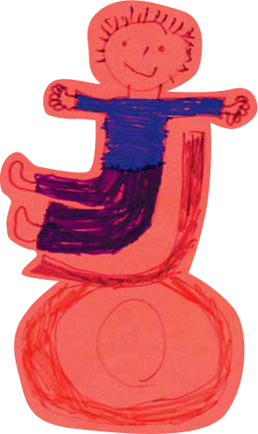

Illustration by James Zagami of the Mont Albert Primary School

Disability Awareness Activities
Games and Sensory Activities for Exploring the World of
Disability Experience

Find The Lighthouse

Equipment needed: Blindfolds

Estimated time for activity: 15 minutes
Number of participants: From five up to the whole class
Setting up the activity:
One person is designated as a lighthouse. They stand at the end of a playing area about 10 meters long. One or more players are ships that need to be blindfolded. All other players are rocks. The rocks find a position in the ocean (playing area).
Playing the game:
During the game, the lighthouse must “beep” every four seconds. The ships must try to find their way through the ocean to the lighthouse without running into any rocks. If a ship comes within one meter of a rock, the rock makes a “foghorn” sound. The ship has a set time (one minute) to navigate their way to the lighthouse. Once this has been achieved, students can be rotated so that everyone gets a go at being a ship.

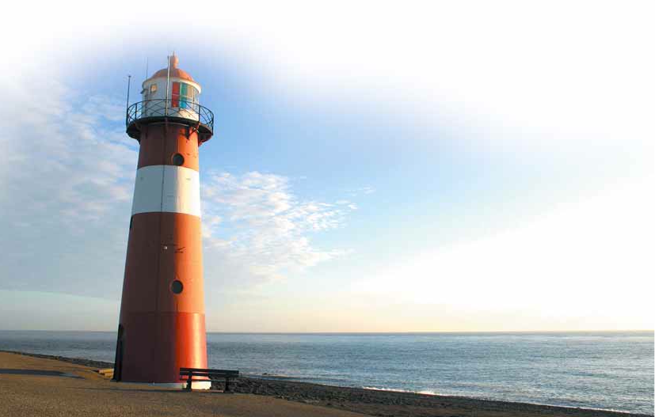
Disability Awareness Activities adapted for Include! from Disability Awareness Resource Kit, Whitehorse City Council, Australia.

Animal Noises
Equipment needed: Blindfolds
Estimated time for activity: 15 minutes
Number of participants: From six up to the whole class
Setting up the activity:
Everyone in the group is blindfolded. Give each student an animal character.
Playing the game:
The students must make their animal noises and try to find other students making the same animal noises and group together. For example, all people saying “Moo” would find each other and make a group of “cows.”
Ensure that all people wearing blindfolds have their hands stretched out in front of them to prevent the students bumping into each other.
(Activities sourced from the Nican website.)
Feel Pictures — Art by Touch
Things you will need:
    - A blindfold for each student.
    - A3 size paper, glue, scissors. Get the students to create a picture using any material that you feel is suitable.
    - Packet of pipe cleaners, pieces of foam, pieces of different textured material, stuffing, cotton, string, wool.
    - You can also use outdoor objects such as leaves, bark or small sticks.
Some Ideas For Pictures
Picture of the front of the student’s house, pictures of the outdoors in different weather or seasons, family or pets, favorite foods or other topics you feel are suitable. Or you could give each student or group of students a different topic.
When Pictures Are Dry
- Blindfold students.
- Let them feel the artwork.
- See if they can find their picture when put with other artwork and/or work out what someone else’s picture is about.
- When activities are over have a question time.
- How did they feel when doing the activity?
- What did they learn?
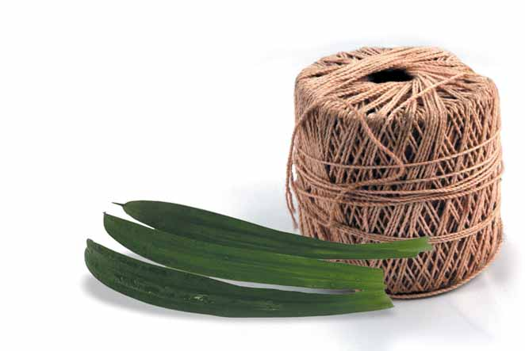Feel Pi Hearing Loss
These activities are designed to give students an understanding about having a hearing impairment and to discover other ways and means to communicate.
Activities
- Lip-reading: Organize students into pairs. Get one student to communicate with their partner by only mouthing the words. Get the other student to try and lip-read and guess what is being said. Swap over.
- Have the students wear earmuffs when listening to the TV or CD player. Change the volume to a level so they can hear with the earmuffs on. Then removing earmuffs to discover the difference in volume levels.
- Have the class break up into pairs and have all the students talk to their partner at once, with the aim being to see if they can just concentrate on their own conversation.
1. Observe the noise level in the room. Does it get louder and louder?
2. Ask the students if they found they had difficulties hearing each other.
3. Ask if any of them had to repeat themselves to their partner.
When activities are over
Have a question time.
• What did you learn about having a hearing impairment?
• How did it make you feel?
• How can you assist a person with a hearing disability?
Communicating Without Memory Game
Estimated time for activity: 20 minutes
Number of participants: All of the class
Setting Up the Class
Directions for the Activity
Divide the students into pairs. Give one of the pair a sentence that they have to communicate to their partner or get them to make up their own sentence. Some examples are:
- I have a headache.
- I want to go outside.
- I would like a drink.
- I am having fun.
The other student has to guess what the student is trying to communicate. Ask some of the students to demonstrate to the rest of the class how they communicated their message.
Ask the students how they found the activity. Was it easy? Was it frustrating? What techniques did they use to communicate their message? How did they feel when they couldn’t be understood or they couldn’t understand their partner? Explain how someone with a brain injury often has difficulty with speech, cannot communicate with words and has to find alternative ways to communicate.

Words Activity
Number of participants: All of the class
Estimated time for activity: 20 minutes
Setting up the activity: Divide students into pairs and ask one of the students in the pair to develop a list of 10 words. Once they have developed the list, get the student with the words to read this aloud to their partner. While the list is being read out, the other student listening has to count backwards from 30. When the list has been read out, the student that had been listening and counting backwards must recite the list back to their partner.
When this has been completed, ask the students how many words on the list they could recite back. Ask if they found the activity hard or easy. Explain how often someone with an acquired brain injury has difficulty with memory and difficulty concentrating when there are many things happening at once.

Colored Words Activity
(This color/word brainteaser is posted on many science and education websites.)
Number of participants: All of the class
Estimated time for activity: 20 minutes
Materials and setting up the activity:
Have students work individually or in small groups. Give each student two sheets of lined paper for writing and several different colored markers.
Directions
Write the names of several colors on one of your pieces of paper using the color that goes with the word. So, if you are writing blue, use a blue marker. Write as many words as you like. Look at the paper and say the words out loud.
Choose the name of a color. Then, on a new piece of paper, write the name of these same colors, but write each word using a different colored pen. You can write the same word more than once.
Look at this sheet of paper and say the colors the words are written in out loud.
Do you notice a difference? Which sheet was easiest to read?
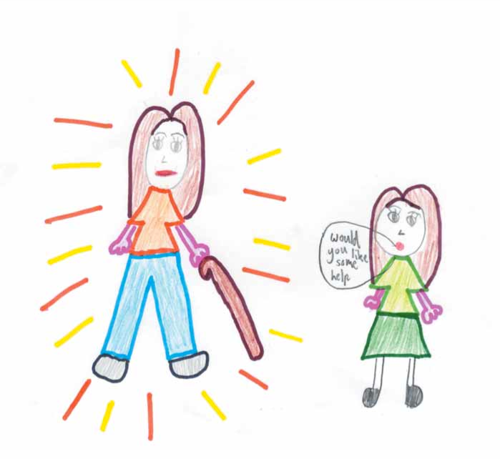
If you have a suggested activity, pictures to share, a story to tell, or a resource to offer, visit our website:
www.IncludeVT.org

Recognition and thanks: Artwork and several of the awareness activities in this booklet are from a wonderful resource created by the city of Whitehorse in Australia. Look for the Whitehorse Disability Awareness Kit, a Resource Kit for Primary School Teachers (2005), at: Whitehorse Disability Awareness Resource Kit.pdf.

